1. Explain the difference between Relative, Absolute and Mixed Cell Referencing. You have the following dataset.

Vehicle Price
Car 500000
Bicycle 10500
Auto-Rikshaw 25000

• Relative cell referencing
A relative reference changes automatically when a formula is copied to another cell. Example- calculates 5% of the price stored in E1.
C2- =B2*5% If we copy the formula down
C3- =B3*5%, C4- =B4*5%
• Absolute cell referencing
An absolute reference remains fixed, even when the formula is copied, by using F4 function
Example- C2- =B2*$E$1, C3- =B3*$E$1, C4- =B4*$E$1
• Mixed cell referencing
In this, only part of the cell reference is fixed: $E1-cloumn fixed, row changes
E$1- row fixed and column changes

Example- if E1 cell contains a number and you want the row fixed, C2- =B2*E$1
When copied- Across column, row 1 remains fixed
Down rows, column E remains change

2. Write a formula to calculate the total sales of Car and Bicycle only.
• =SUMIF(A2:A4, "Car", B2:B4) + SUMIF(A2:A4, "Bicycle", B2:B4)

3. Using the data below, write a formula to calculate the average sales of items priced above 100 but less than 300
Items Price Sales
A 90 1000
B 150 1200
C 250 1500

• = AVERAGEIFS(C8:C10,B8:B10,">100", B8:B10, "<300")
1350
From dataset link
4. Count how many customer names are recorded.
• Select the column of customer name and total no. of customer will appear in status bar.

5. Calculate the Total Sales for each row using a formula.
• =E2*F2 then drag the formula down for other rows

6. Calculate the total sales of Notebooks in the North region only.
Giving the total sales in H column
• =SUMIFS(H2:H51, D2:D51, "Notebook", C2:C51, "North")

7. Create a column chart showing total sales by product.

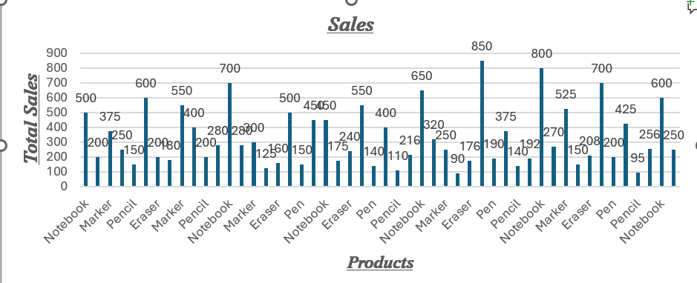

8. Insert a line chart showing daily sales trend.

